PROJECT REPORT OF CO-OP Project at Industry (Module-2)
ON
Analyzing Business Performance Gains from Cloud Adoption Using Data-Driven Approach

submitted in partial fulfilment of the requirements for the award of degree of

BACHELOR OF ENGINEERING
In
COMPUTER SCIENCE AND ENGINEERING

Submitted by: Supervised By:
Name: Pratham Bajaj, Nayaja Dr. S.B. Goyal
Roll Number: 2210992072, 2210991968 Dean,
Chitkara University, Rajpura


DEPARTMENT OF COMPUTER SCIENCE AND ENGINEERING

CHITKARA UNIVERSITY INSTITUTE OF ENGINEERING AND TECHNOLOGY
CHITKARA UNIVERSITY, PUNJAB, INDIA
CONTENTS

S. No. | Title | Page No.
 | Acknowledgement | IV
 | Abstract | V
1 | Introduction | VI
2 | Methodology | VII
3 | Tools and Technologies | VII
4 | Implementation | VIII-IX
5 | Major Findings/Outcomes/Output/Results | IX
6 | Conclusion and Future Scope | X
7 | References | XI
8 | Appendices | XII-XIII

DECLARATION

I hereby certify that the work which is being presented in the project report entitled “Analyzing Business Performance Gains from Cloud Adoption Using Data-Driven Approach” in partial fulfilment of requirement for the award of the degree of Bachelor of Engineering (Computer Science and Engineering) submitted in the department of Computer Science and Engineering at Chitkara University Institute of Engineering and Technology, Chitkara University, Punjab, India, is an authentic record of my own work carried out under the supervision of Dr. S.B. Goyal. The matter presented in this project report has not been submitted in any other university/institute for the award of any degree.

Place: Rajpura (Pratham Bajaj, Nayaja)
Date: …………….. (University Roll No.: 2210992072, 2210991968)

This is to certify that the above statement made by the candidate is correct to the best of my knowledge and belief.

(Dr. S.B. Goyal )
Dean,
Department of Computer Science and Engineering
Chitkara University Institute of Engineering and Technology,
Chitkara University, Punjab, India

ACKNOWLEDGEMENT

It is our pleasure to be indebted to various people, who directly or indirectly contributed to the development of this work and who influenced my thinking, behavior and acts during the course of study.
We express our sincere gratitude to all for providing me an opportunity to undergo Integrated Project as the part of the curriculum.
We are thankful to Dr. S.B. Goyal for his support, cooperation, and motivation provided to us during the training for constant inspiration, presence and blessings.
Lastly, we would like to thank the almighty and our parents for their moral support and friends with whom we shared our day-to day experience and received lots of suggestions that improve our quality of work

Pratham Bajaj | Nayaja
ID No 2210992072 | ID No 2210991968

ABSTRACT

Abstract— Cloud computing has profoundly changed the information technology landscape and how organizations run their business operations. Many organizations have reported improved financial and operational performance after shifting their information technology infrastructure from traditional computing to cloud computing. This study aims to examine the impact of the adoption of cloud computing on business operational performance in terms of cost reduction, collaboration efficiency, and system reliability. Comparative analysis was done on the organization’s operational performance before and after the adoption of cloud computing.
Keywords— Cloud Technology Implementation, Cloud Service Models (SaaS, PaaS, IaaS), Experimental Study, Business Transformation, Operational Efficiency.

- Introduction (16 Times New Roman, Bold)

  - 1ntroduction (14 Times New Roman, Bold)

In recent years, advancements in information technology have significantly influenced the way businesses operate. Traditional IT infrastructure requires heavy investment in hardware, maintenance, and skilled personnel. Cloud computing has emerged as an alternative solution that provides on-demand access to computing resources such as storage, networking, and software services.
This project explores how cloud computing improves business operations through a quantitative approach. Unlike traditional studies that focus on theoretical benefits, this project uses logistic regression to analyze efficiency improvements after cloud adoption. Cloud platforms such as AWS, Microsoft Azure, and Google Cloud allow organizations to scale resources dynamically and reduce operational complexity.
The study focuses on evaluating the impact of cloud computing on cost reduction, operational efficiency, and business continuity

  - Problem Statement

Traditional IT infrastructure involves high costs, limited scalability, and complex maintenance, which restrict business flexibility and efficiency. Organizations often struggle with resource utilization, system upgrades, and adapting to changing business needs such as remote work and real-time data access.
Although cloud computing provides a scalable and cost-effective alternative, there is still a lack of clear quantitative analysis of its impact on business performance. Most existing studies focus on general benefits like cost reduction and improved collaboration, but they do not measure actual efficiency improvements using data-driven methods.
Therefore, this project aims to address this gap by analyzing the impact of cloud computing on business operations using a data-driven approach. By applying logistic regression on pre- and post-adoption data, the study evaluates improvements in operational efficiency and overall performance.

  - Title
Title: “Analyzing Bussiness Performance Gains from Cloud Adoption Using Data-Driven Approach”
The title “Analyzing Business Performance Gains from Cloud Adoption Using Data-Driven Approach” reflects the main focus of the project. It emphasizes evaluating how cloud computing improves business performance in terms of cost, efficiency, and scalability. The term data-driven approach indicates that the analysis is based on real data rather than assumptions. By using techniques like logistic regression, the study quantitatively measures the impact of cloud adoption, providing reliable insights into how organizations benefit from modern cloud-based infrastructure

- Methodology

The research adopts a quantitative experimental methodology to analyze the impact of cloud computing on business performance. The study focuses on organizations that have transitioned from traditional IT infrastructure to cloud-based systems. A before-and-after comparative approach is used, where key performance indicators such as operational cost, efficiency, and system reliability are evaluated prior to and following cloud adoption. This approach enables a clear understanding of the direct effects of cloud integration on business operations.

For data collection, relevant organizational data was gathered from multiple sources, including operational cost records, system performance metrics, and efficiency indicators. The data primarily captures expenditure patterns before cloud adoption and the subsequent reduction in costs and improvements in performance after migration. The dataset also incorporates factors such as remote work enablement, resource utilization, and system accessibility, providing a comprehensive view of business transformation driven by cloud technology.

- Tools and Technologies

- Platform Used: Google collab/ Anaconda
- Required Libraries: pandas, Numpy, matplotlib, scikit-learn.
- Language Used: Python
- Requirement: Python 3.10

- Implementation

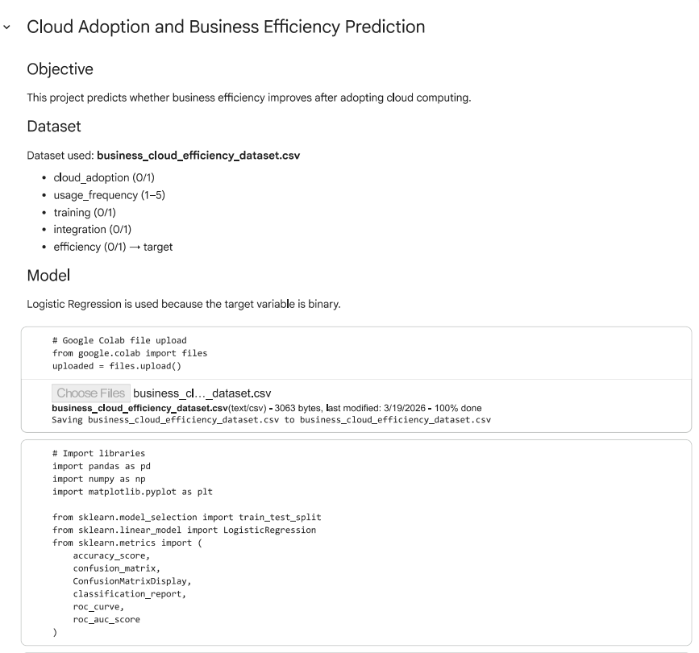

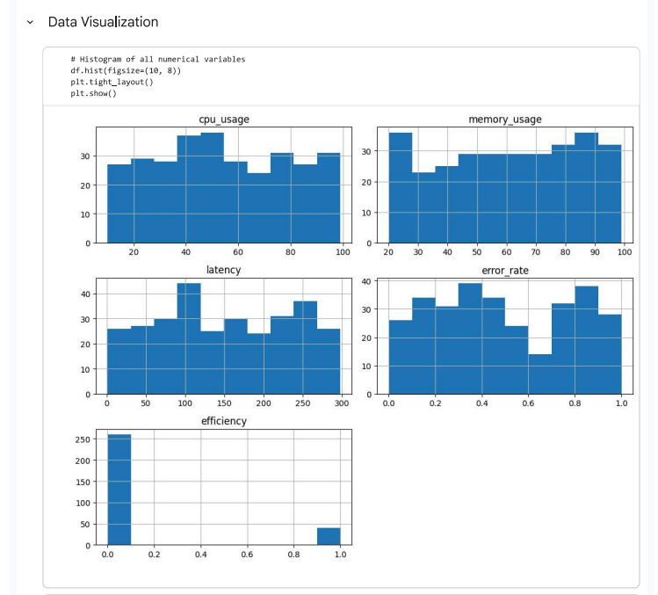

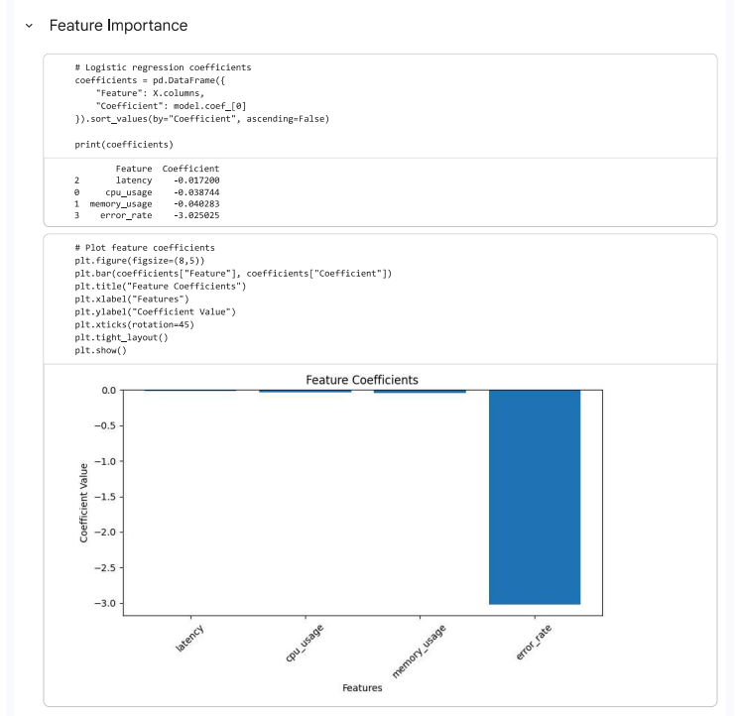

- Major Findings and Outcomes

The study highlights a significant reduction in operational costs after the adoption of cloud computing. Organizations transitioning from traditional IT infrastructure to cloud-based systems benefited from a pay-as-you-go model, eliminating heavy upfront investments and recurring maintenance costs. The cost analysis indicates a total annual saving of ₹8,84,068, with overall IT expenses reduced by nearly 30–40%. Additionally, the growing SaaS market and real-world cases of companies saving up to $1.5 million annually further validate the financial efficiency of cloud adoption.

The findings also demonstrate a substantial improvement in operational efficiency driven by cloud integration. With the rise of digital transformation and cloud-first strategies, organizations have enabled flexible and remote working environments, leading to increased productivity. The analysis reveals an improvement of up to 30% in operational efficiency, with logistic regression results indicating that efficiency can grow up to 2.5 times with proper cloud implementation and training. This shift has been crucial in supporting modern work dynamics, including a 159% increase in remote work adoption.

Another key finding is the enhancement in disaster recovery and business continuity. Cloud-based solutions provide robust mechanisms such as data backup, system recovery, and failover support, minimizing downtime during disruptions. Metrics like Recovery Point Objective (RPO) and Recovery Time Objective (RTO) enable organizations to strategically manage data loss and recovery speed. As a result, cloud computing plays a critical role in ensuring reliability, security, and uninterrupted business operations.
- Conclusion and Future Scope

  - Future Scope

In the future, this study can be extended by applying advanced machine learning techniques such as Random Forest and Neural Networks to improve prediction accuracy. The use of larger and more diverse datasets from multiple industries can further enhance the reliability of results. Additionally, integrating cloud computing with emerging technologies like Artificial Intelligence and IoT can provide deeper insights into smart business systems. Real-time data analysis and cloud monitoring can also be explored to better understand dynamic business environments.

  - Conclusion

This project analyzed the impact of cloud computing on business operations using a data-driven approach. By comparing performance before and after cloud adoption, the study found a significant reduction in operational costs and a noticeable improvement in efficiency. The application of logistic regression provided a quantitative understanding of how cloud adoption influences business performance.
The results indicate that cloud computing enhances flexibility, supports remote work, and improves system reliability through better resource management and disaster recovery mechanisms. Overall, the findings confirm that cloud computing is not only a technological upgrade but also a strategic tool for improving business efficiency and productivity. Therefore, organizations adopting cloud solutions can achieve better performance and long-term growth.
Furthermore, the study highlights that cloud computing enables organizations to respond quickly to changing market demands by providing scalable and flexible infrastructure. It also reduces dependency on physical resources and enhances decision-making through better data accessibility. The findings reinforce that cloud adoption supports digital transformation and helps organizations remain competitive in a rapidly evolving technological environment.

- References

- Mell, P., Grance, T.: The NIST Definition of Cloud Computing. National Institute of Standards and Technology (NIST), U.S. Department of Commerce (2011)
- Armbrust, M., Fox, A., Griffith, R., et al.: A View of Cloud Computing. Communications of the ACM 53(4), 50–58 (2010)
- Buyya, R., Yeo, C.S., Venugopal, S.: Market-Oriented Cloud Computing: Vision, Hype, and Reality for Delivering IT Services as Computing Utilities. Future Generation Computer Systems (2009)
- Zhang, Q., Chen, M., Li, L.: Cloud Computing: State-of-the-Art and Research Challenges. Journal of Internet Services and Applications 1(1), 7–18 (2010)
- Islam, R., Patamsetti, V., Gadhi, A., Gondu, R.M., Bandaru, C.M., Kesani, S.C., Abiona, O.: The Future of Cloud Computing: Benefits and Challenges. International Journal of Communications, Network and System Sciences (2023)
- CXO Content: Evolution and the Future of Cloud Computing [Internet]. Available at: https://cxocontent.com/future-of-cloud-computing-inception-to-edge-computing/ (2021). Accessed 2026
- Wikipedia: Cloud Computing [Internet]. Wikimedia Foundation. Available at: https://en.m.wikipedia.org/wiki/Cloud_computing (2022). Accessed 2026
- Tutorials Point: Cloud Computing Challenges [Internet]. Available at: https://www.tutorialspoint.com/cloud_computing/cloud_computing_challenges.htm (2022). Accessed 2026
- SWZD: Cloud Trends in 2021 and Beyond: Remote Work Drives Adoption [Internet]. Available at: https://swzd.com/resources/cloud-trends/ (2021). Accessed 2026
- Rapyder: What is Disaster Recovery & Its Importance for Business [Internet].Available at: https://www.rapyder.com/blog/disaster-recovery-in-cloud-computing/ Accessed 2026
- Verity IT: Can Cloud Computing Reduce Your IT Costs? [Internet]. Available at: https://www.linkedin.com/pulse/can-cloud-computing-reduce-your-costs-verity-it-2gxve Accessed 2026

- Appendices

  - Appendix A: Cost Analysis Data

This appendix presents the comparative cost data used in the study to evaluate the financial impact of cloud adoption. The analysis includes operational expenses incurred before and after migrating to cloud infrastructure.

Cost Savings Table
On-premises (Before Cloud) | Cloud (After Cloud)
=8,63,900+10,50,000+18,000 = 19,31,900 | = 4,95,916 + 6,51,916 + 0 = 10,47,832
Total Saving for 12 months of using Cloud = 8,84,068 INR.

This dataset supports the finding that cloud computing significantly reduces IT operational costs.

  - Appendix B: Logistic Regression Model Overview

This appendix outlines the statistical model used to analyze the impact of cloud adoption on operational efficiency.
- Model Used: Logistic Regression
- Dependent Variable: Operational Efficiency (Improved / Not Improved)
- Independent Variables:
  - Cloud Adoption (Yes/No)
  - Resource Utilization
  - Remote Accessibility
  - Cost Optimization
The model evaluates the probability of efficiency improvement after cloud adoption. Results indicate that organizations adopting cloud computing show a significantly higher likelihood of improved operational performance, with efficiency gains reaching up to 2.5× in optimized environments.

  - Appendix C: Data Collection Framework

Data for the study was collected using the following approach:
- Historical financial records (pre- and post-cloud adoption)
- IT infrastructure cost reports
- Performance metrics from cloud-based systems
- Industry benchmarks and reports

The collected data was structured to enable comparative and statistical analysis, ensuring reliability and consistency in results.

  - Appendix D: Cloud Services Model

The study considered the following cloud service models:
- SaaS (Software as a Service): Used for application-level services
- PaaS (Platform as a Service): Used for development and deployment
- IaaS (Infrastructure as a Service): Used for virtualized computing resources

